We’re on the Web!

Havenwood Church Preschool Newsletter

**A Maryland Accredited & EXCELS Level FIVE Preschool**

[www.havenwood.org/](http://www.havenwood.org/)preschool

Susan S. Riegger, Director

December, 2022

***HAVENWOOD’S TEACHERS & STAFF***

***WISH YOU A PEACEFUL THANKSGIVING,***

***WONDERFUL CHRISTMAS SEASON***

***AND***

***MANY BLESSINGS IN THE NEW YEAR!***

**(SINCE THIS IS OUR LAST NEWSLETTER OF 2022, THIS IS**

**ALL ROLLED INTO ONE BIG WISH FROM OUR HEARTS!)**







Contents

**Upcoming Events 1**

**Susan’s News 2**

**Mrs. Law’s News 3**

**Mrs. Taylor’s News 3**

**Mrs. McElwain’s News 4**

**Mrs. Huber’s 4’s News 5**

**Mrs. Hare’s News 5**

**Mrs. Zinzi’s News 6**

**Mrs. Park’s 3’s News 6**

**Two’s News 7**

**Daycare News 8**

**Lunch Bunch 4**

**Inclement Weather 8**

**Art News 9**

**Church News 9 & 10**

***Would you like to Christmas shop alone?***

***Don’t forget to sign up for Lunch Bunch early – slots fill up quickly!***

***Your child may attend on their***

***“off” days too!***



***Havenwood Closed for Christmas Holiday after Christmas Programs***

***December 21st through January 2nd***

***School reopens***

***January 3, 2022***

***REGISTRATION FOR 2023-2024***

**ALL IN HOUSE MAY REGISTER NOW**

**FIRST COME FIRST SERVE**

**Information has been sent home**

**Kindergarten is filling quickly!!**

**Registration for the Public is**

**January 10th at 10:00 a.m.**

**The registration process will be in person for**

**new incoming students!**

# Susan’s News Page 2

**Page 2**

**Dear Parents,**

**I hope everyone has a wonderful, family filled, Thanksgiving holiday and that you have lots of leftovers!**

**As December and the holiday season begins, stress levels will rise for all! Try to keep routines at home consistent for our littles, let them do physical activity (even with it being dark at 4:30), remind yourself that their crying, whining and clinginess are just their own developmental way of venting and maybe time to schedule in some downtime.**

**Your child’s teacher will provide our Christmas pageant & party schedules. Many events will happen during the weeks of December. Santa will visit in early December, we will decorate our trees & the classroom trees. The twos classes will have their parties on December 15th & 16th and that will be the last day your child will attend, including daycare two year olds until January 3, 2023.**

**Thank you, parents, for adhering to our “sick child” policy. Please remember, fever free for 24 hours WITHOUT fever reducing medicines. If your child has vomited or had diarrhea, please keep them home for 24 hours following the last occurrence and please continue to follow all MDH and CDC guidance concerning COVID-19.**

**Thank you for completing the fall surveys. I am so pleased that the comments were positive & supportive. Every year we evaluate ourselves through parent surveys, teacher surveys, observations and assessments. Thank you for being a part of the process. I have attached to this newsletter a copy of the Preschool’s latest Yearly Evaluation. This evaluation was presented and approved by the Session of the church and the Havenwood faculty. If you have any questions please contact me.**

**A very, very special thank you to all of the parents who donated or purchased items toward our Fall Fundraiser. We were able to use the funds to purchase many new items for the school.**

**Our teachers and our students are busy preparing for their classroom Christmas fun but we always remember to stop and thank each other for each other’s talents and contributions. We are a family of 140 students and 21 teachers and staff and together we wish you a Happy Holiday Season, full of peace and joy, love & normalcy!**

**Happy Holidays,**

**~Susan S. Riegger**



**ENJOY THE**

**WONDER OF CHRISTMAS THROUGH YOUR CHILDREN’S EYES**

Page 3

Kindergarten’s News

## News from Mrs. Law



**Hello Parents!**

**We have been busy learning how to be a good friend and to treat everyone with kindness. In language arts we have continued to practice identifying fiction and non-fiction books and have been learning about nouns, verbs and adjectives. We are continuing to meet new Alphafriends each week and are now putting the Alphafriends together to form words.**

**In math, we have been busy identifying shapes and have learned that shapes are all around us whether we are at home or at school. We have also learned to identify symmetry and equal parts.**

**We learned all about the first Thanksgiving and lives of the Pilgrims and Native Americans in November and in December we will learn about the story of Christmas and help tell the story during our school Christmas pageant. Our Polar Express/pajama day will be Friday, December 16th. We will have our Christmas celebration on Wednesday, December 21st. More information to follow. There will be NO early bird or aftercare that day.**

**We are thankful for the opportunity to be a part of your children’s lives!**

**~Amy Law**

**Hello Everyone:**

**November has flown by and Christmas is right around the corner. This month we have been very busy talking about Thanksgiving and how each of our family celebrates. We made a Thankful Book and each child illustrated and dictated their page. We also learned and created our alphabet page for the letters G and T and the sounds they make.**

**December is going to go very quickly so try to keep up. We will be working on many holiday projects, learning the letters and their sound Cc and Rr, and our December sight words we and green. We also will be preparing for the Christmas Program and practicing our Christmas songs.**

**~Mark your calendar for these important dates:**

**December 21st – Christmas program (more information to follow)**

**December 22nd through January 2nd, 2023 – Christmas break**

**As always, thank you for your support at home and sharing your wonderful children with us!**

**~Margaret Taylor, Amy Wells & Mrs. M**

## PreK I – Mrs. Taylor, Mrs. Wells & Mrs. M

**Four Year Old Classroom News**

**More Four Year Old Classroom News** Page 4

## PreK II – Mrs. McElwain & Mrs. Esslinger

**Dear Parents,**

**It is hard to believe that it is December already! December is always a busy and fun month at Havenwood and in our classroom! In December we will learn about letter R (since we squeezed in C before Thanksgiving) and the sight words green and we. The homework calendar sent home on November 28th will be the last one until the new year. For December, our only homework will be to practice our Christmas program songs.**

**Thank you so much to Jill Boyd and Sofie Diakoulas for organizing all of our parties, and to everyone who has contributed to making things special for the children. On Tuesday, December 20th we will enjoy a special snack and have a pajama day to celebrate December! On Wednesday, December 21st we will have our Christmas pageant. There is no early bird or after care on this day. Students will arrive with their parent at 9:00 and come directly to Fellowship Hall. The pageant will begin at 9:30. Please join us in Fellowship Hall following the performance for light refreshments. Students will leave with their parents after our celebration.**

**As always, thank you for your support at home and sharing your wonderful children with us!**

**~Katie McElwain and Carin Esslinger**

**LUNCH BUNCH NEWS**

**December is a busy month! Consider having your child stay for lunch bunch. You can get a little extra shopping time in or have a holiday lunch. The children look forward to having lunch with their friends. They enjoy free playtime and outside play. Sign up early to secure a spot! You may either email Kathy** [**havenwoodcenteroffice@comcast.net**](mailto:havenwoodcenteroffice@comcast.net) **or call the office to sign up.**

**We hope to see you in lunch bunch!**

**Mrs. Dwan Monday/Wednesday/Friday**

**Mrs. Dooley – Tuesdays**

**Mrs. Pifer – Thursdays**

**Monday thru Friday 11:45 – 3:00 $25.00 per session;**

**$20.00 for Mrs. McElwain’s 1:30 dismissal**

**enjoying our time in MAO. The children enjoy bringing their lunches, meeting new friends, visiting Mrs. Binkley in Library and Mrs. Hunter in Music. They also have a chance to spend a little extra time on the school computers. We will continue to go outside, so please dress your children accordingly.**

**Please remember that November and December are busy months in MAO, so sign up early!**

**Happy Thanksgiving and Happy Holidays! I hope to see your children in MAO.**

**~Mrs. Pifer**

**Monday- Friday 11:30 to 3:00**





**Hello Parents!**

**I can’t believe we’re writing to tell you all about our Christmas plans. We have had a fun November talking all about Native American Indians and the Pilgrims We learned a new Thanksgiving prayer that we hope they shared with you at your dinner table!**

**This month we will introduce the star as our shape, the color green & the number 4, along with some more letters of the alphabet. We will be making some special keepsakes and learning our Christmas songs.**

**Now we must move on to our Christmas program. We will practice singing our Christmas songs here in the classroom and in music class, throughout the month of December. Parents are invited to our Christmas program in our room on Wednesday, December 21st at 10:30. We will have a performance and small party. Please note, parking is a minimum so be prompt, as we will start as close as possible to 10:30. Your invitation will be coming home soon!**

**\*\* PLEASE remember that there is NO Early Bird or Aftercare on December 21st\*\***

**Havenwood will reopen on Monday, January 3, 2023!**

**Mrs. Pifer and I wish you a Merry Christmas and a blessed New Year!**

**Onward to 2023!**

## PNI – Mrs. Hare & Mrs. Pifer

**Three Year Old Classroom News**

**Hello families!**

**I hope everyone had a wonderful celebration of Thanksgiving with your families. Mrs. Cocchi and I are so very thankful to teach your amazing children.**

**As the temperatures drop, I encourage you to send your children to school with coats, hats and gloves. The kids love to run, play and explore our playground before we start our learning. Winter gear is essential.**

**In December we will be busy learning and celebrating. Our letters will be C and R. We will be creating letter pages, sharing letter bags, pronouncing sight words, expanding patterns, sorting and sequencing. We also have some wonderful holiday books to share. In fact, we will do some festive activities around *The Grinch* and *The Gingerbread Baby*.**

**This year, our class celebration will be a wonderful holiday treat. We will be celebrating with the Havenwood, classic Christmas pageant. On Dec. 21, we welcome two adults with each student to join us for the story of Christmas and some precious songs. More details will follow. Also, be on the lookout for some beautiful decorations**

**made by your little elves. Our Christmas break will begin after school on**

**Wednesday, Dec. 21.**

**Happy Holidays!**

**Have a wonderful December,**

**Chrissy Huber and Kristen Cocchi**

**Have a wonderful December,**

**Chrissy Huber and Katie Kauffman**

## PreK III – Mrs. Huber & Mrs. Cocchi

**More Four Year Old Classroom News** Page 5



**Happy Holidays!!!**

**We have absolutely loved learning about the Thanksgiving holiday and talking about all the things we are thankful for. Your children are amazing, and we love their hearts! It is truly such a blessing to spend our mornings with them and we are so thankful for that opportunity… THANK YOU!**

**We are now ready to begin… THE MOST WONDERFUL TIME OF THE YEAR, Christmas! We have so many fun things planned and look forward to celebrating this holiday season and the joy and magic that it brings, with your children.**

**During the month of December, we will focus on letters I and J, the color green, our shape of the month, the star, and the number 4. Of course, we will be singing plenty of Christmas songs and creating some treasured keepsakes that will be brought home before Christmas break. We will for sure be busy little elves! We look forward to celebrating with you, in our classroom, at our class Christmas celebration on Wednesday, Dec 21st at 10:30am. Your amazing children will share a short performance with you, and we will have some light snacks together before we break for the holidays. More information to come :)**

**Havenwood’s Christmas break will begin after our celebration on Wednesday,**

**December 21st and our class will reopen Wednesday, January 4th, 2023! We hope you**

**all have a holiday season full of peace, love and joy and we look forward to seeing**

**you all in the new year.**

**Christmas Blessings,**

**Erin Parks & Annika Gillespie**

## PNIII – Mrs. Parks & Mrs. Gillespie

Happy holidays parents!

While we loved paying tribute to all we’re thankful for, it is time to move into December and embark on the most magical time in a three or four year old’s life - the Christmas season!! The next several weeks will be jam packed with prep and special events to add even more to the joyous spirit. It is seriously my favorite time at Havenwood. Watching your children get caught up in the magic of it all makes the work all worth it!

While we spend a lot of time learning special songs, making special keepsakes, and practicing for our big “performance,” we do actually fit in some academics! This month we focus on our new color GREEN, our new number FOUR, our new shape the STAR, along with a few more letters. The fun is finding festive ways to incorporate all of our basics into the season!

With Covid restrictions finally lifting, we are able to invite you to our classroom for a holiday celebration with your child! Please plan to join us to watch your child sing some songs and enjoy some light snacks before we convene for the Holiday Break. Our **2 Day Class** will celebrate on **Tuesday, December 20th**, and our **3 Day Class** will celebrate on **Wednesday,** **December 21st**. Both celebrations begin at **10:30am.** This will not be a regular school day. You will bring your child to the classroom at the time of the performance, and take your child with you when the party comes to a close. :)

We hope your season is filled with lots of precious moments, memories, and a little sprinkle of magic!

Warmest Holiday Wishes,

Aimie Zinzi and Allison Sarratea

**Warmest Holiday Wishes,**

**Aimie Zinzi and Allison Sarratea**



## PNII – Mrs. Zinzi & Mrs. Sarratea

**More Three Year Old Classroom News Page 6**

**TODDLER TWOS Page 7**

**Mrs. Yeakel & Mrs. Dwan - M/W/F & T/Th “A”**

**Mrs. Kauffman & Mrs. Huber – M/W/F & T/Th “B”**

**The Toddler Twos have been *Totally Terrific* the month of November! We’ve been singing LOTS of Turkey songs, counting to 3, learned the new shape, triangle and we now know our colors; Red, Orange, Black and Brown! We also LOVE to sing our A-B-C song! Like Mrs. Yeakel and Mrs. Dwan say…”Kiss Your Brain Friends!” because we are amazing!**

**Next month we will learn the color Green, the number 4 and the shape, rectangle.**

**Next month is very busy so here are a couple of**

**IMPORTANT REMINDERS & DATES**

**First…PLEASE remember to dress your child appropriately. WE WILL GO OUTSIDE WHEN EVER POSSIBLE. (these kiddos need to run around☺) This means, HAT, MITTENS (gloves are not recommended) and winter COAT. Think LAYERS. We can always take off.**

**Second…PLEASE work on having your child learn to wipe his/her nose. We do not mind at all doing it, but it is a great skill to have them learn so NOT to spread germs. (Please remind them to throw the dirty tissue in the trash ☺)**

**Third…PLEASE remember there will be an IN-Person Holiday Concert. Please refer to your class email for more details.**

**Both T/TH Classes**- **Green Day**: December 6, 2022

**Holiday Party**: December 15, 2022

**Mrs. Yeakel’s** M/W/F Class- **Green Day**: December 7, 2022

**Holiday Party**: December 16, 2022

**Mrs. Kauffman’s** M/W/F Class- **Green Day**: December 7, 2022

**Holiday Party**: December 14, 2022

** Friday, December 16th will be regular class time.

**Finally, thank you all so much for some amazing conferences! We loved talking to all of our fabulous parents. Now we know why your kids are so wonderful ☺! And as always, thank you for all your support!**

**Happy Holidays!**

**Monica Yeakel & Pam Dwan**

**Katie Kauffman & Mrs. Huber**



**DAYCARE Page 8**



**Winter brings ice**

**and snow, Christmas trees**

**and Hanukkah candles. We sew costumes**

**and know that as long as there is love,**

**there’ll be a Santa Claus.**

**Just a reminder, if someone different will pick up your child, please call or write a note. We’re very protective of our little friends!**

**Please remember that our last day of early bird & aftercare, before Christmas break, will be Tuesday, December 20th.**

**(The twos are finished on Thursday & Friday, December 15 & 16)**

**We hope that all of you have a joyous season!**

**~The Day Care Teachers**

**\*\*As winter weather approaches – if Baltimore County opens 2 hours late - Early Bird will open at 9:00\*\***

**INCLEMENT WEATHER POLICY**

***\*\*\*EACH CLASS RECEIVED AN INDIVIDUAL POLICY –***

***PLEASE POST IT ON YOUR REFRIGERATOR!!\*\*\****

Havenwood will notify parents of delayed openings or closures by 6:30 a.m. on inclement weather days. Please check your texts from “*Rained Out”* or Facebook, our website or tune into WBAL and WMAR TV.

On some occasions, we may change from a delayed opening to closed – that decision will be made by 8:30 a.m. The decision making processing will include and not limited to the following: the safety of the students and teachers getting into school, the ability to have our parking lot and sidewalks cleared and salted and the weather predicted through the day.

a. Kindergarten sessions will meet from 10:45-2:45

b. PKI (Mrs. Taylor) will meet from 11:00 - 1:00

c. PreK II (Mrs. McElwain) will meet from 11:00 – 1:30 d. PKIII (Mrs. Huber) will meet from 11:00-1:00

e. 3 year olds will meet from 11:15-12:45

f. Toddler a.m. sessions will meet from 11:15-12:30

g. Lunch Bunch will meet from 12:45-3:00. No refunds will be made for shorter sessions due to inclement weather conditions.

Havenwood's daycare will open at **9:00 A.M.**

Havenwood Preschool and Day Care may also close early at the discretion of the director. On rare occasions, we may feel it necessary to make decisions different from the county regarding openings and closings. In these instances, you will be notified by “Rained Out”, TV, or by phone.

**Please watch for a “Rained Out” message on your phone, check Facebook, our website or listen to WBAL TV & WMAR TV for Havenwood’s closings**

C:\Documents and Settings\User\Local Settings\Temporary Internet Files\Content.IE5\OEKT53N5\MC900303521[1].wmf

**ART NEWS FROM MRS. WELLS Page 9**



**Abstract shapes, primary colors and Modern Art. The children enjoyed looking at the artwork of Joan Miro and Albert Calder. Both the PN and PK classes created mobiles with falling leaves. They learned that art can move just like falling leaves in nature!**

**The Kindergarten class celebrated the Thanksgiving holiday with watercolors of sailing ships and coffee filter turkeys. They created an abstract expressionist group painting after learning about Jackson Pollack’s unique style of expression!**

**Upcoming the PN classes will look at Cezanne’s Still Life with Fruit series and use real fruit to print our own paintings.**

**The PK classes will create “Dancers” in the style of Keith Haring. The Kindergarten class will try their hands at printmaking, using Claes Oldenburg’s Alphabet Ice Cream print and sculpture for inspiration.**

**Enjoy your children throughout this magical holiday season. Best wishes to all my preschool students and their families.**

**As always, I thank you for your wonderful children!**

**~Amy Wells**

**NEWS FROM THE CHURCH Page 10**

**NEWS FROM PASTOR JENN**

**Dear Havenwood Families,**

**Thank you, Preschool families! To date, we have collected 76 Thanksgiving Baskets for ACTC.  At the ACTC Thanksgiving Worship service, the executive director, Linda Lotz, said they expect to feed more than 15,000 individuals with the baskets provided by churches and partnerships.**

**The needs in our community and the surrounding communities continue to grow. Havenwood is again partnering with Glenwood Life Counseling Center to help families give gifts to their loved ones. Clients provide general gift suggestions which we have put on a graphic in this newsletter.  This year, we will also give clothing and gifts for the 8 students we provide weekend food bags to at Fullerton Elementary School. Any financial donations (cash or checks earmarked “Fullerton Elementary” to help us purchase**

**correct-sized clothing and wanted gifts are much appreciated)**

**Blessings,**

**Pastor Jenn DiFrancesco**



**MORE CHURCH NEWS**

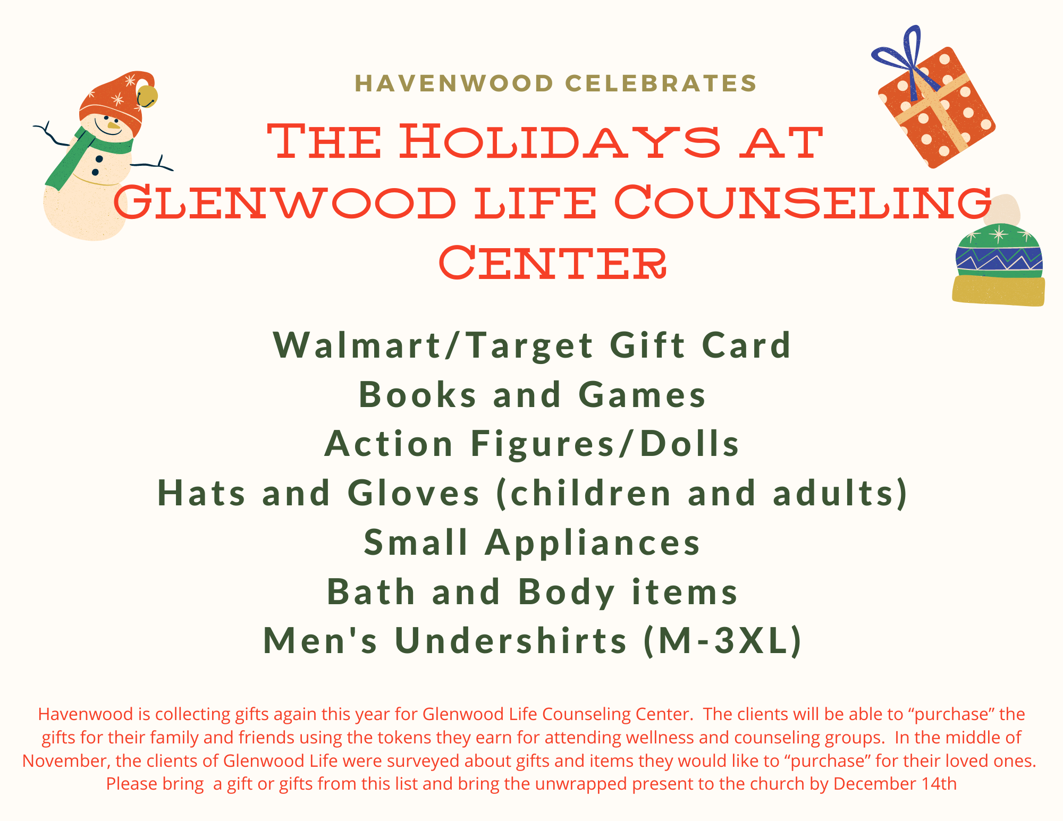

Dear Havenwood Preschool Families,

Havenwood Families Rock!  With the help of generous donations from the Preschool families and staff, the Havenwood Church community blew our goal of 70 baskets out of the water!  On Friday, November 18, we delivered 65 baskets, a box of extra food items and $300 check to ACTC. ACTC uses the cash to purchase turkeys and/or more baskets.

In 2021, ACTC was able to help over 3,000 families enjoy a traditional Thanksgiving and will do so again in 2022 because of your generosity.

THANK YOU!

Havenwood Presbyterian Church Council

Dear Havenwood Preschool Families,

Havenwood Families Rock!  With the help of generous donations from the Preschool families and staff, the Havenwood Church community blew our goal of 70 baskets out of the water!  On Thursday November 18, we delivered 78 baskets, a box of extra food items and $396 check to ACTC. ACTC uses the cash to purchase turkeys and/or more baskets.

In 2021, ACTC was able to help over 3,000 families enjoy a traditional Thanksgiving and will do so again in 2022 because of your generosity.

THANK YOU!

Havenwood Presbyterian Church Council