Havenwood Kindergarten Supply List
2024-2025
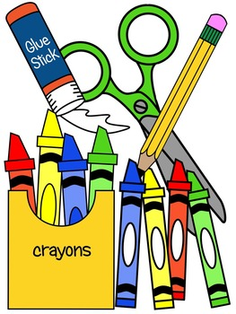
__ 1 plastic supply case*
___ 12 sharpened pencils
__ 1 pink eraser
__ 24 pack of crayons
___ 4 pack of dry erase markers
__ 1 pair scissors
__ 10 glue sticks
__ 1 - 8 ½ by 11 clipboard*
__ 8 count fine line markers
__ Change of clothes (shirt, pants, underwear & socks in a labeled
Ziploc bag)
___ 1 box of sandwich bags
__ Reusable water bottle*
__ Backpack*
___ Normal size beach towel to keep at school*
__ 2 roll of paper towels
___ 2 containers of Clorox cleaning wipes
*Please label these items with your child’s name.
Thank you!

